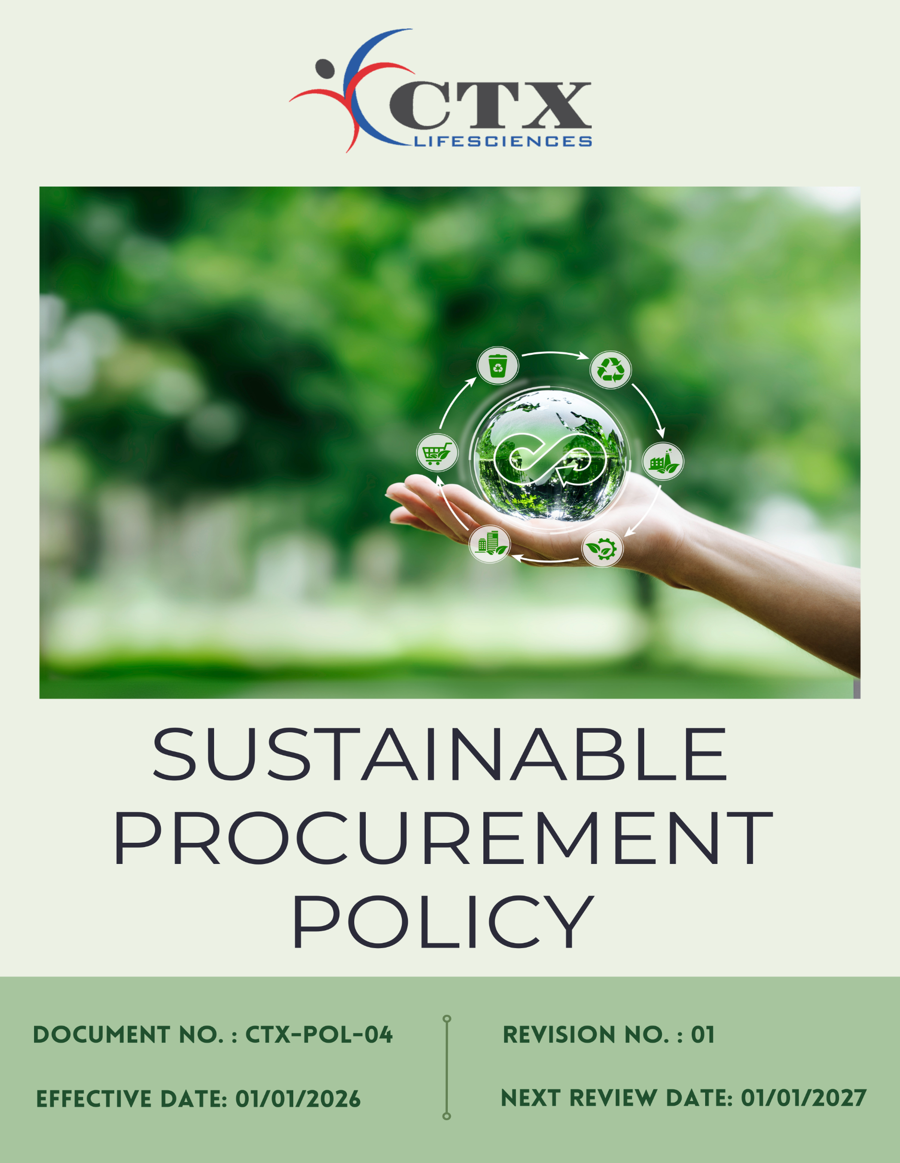
Contents

Preface 3
Policy Declaration 3
Scope 3
Key Focus Areas 4
Qualitative Objectives 4
Quantitative Targets 5
Alignment with the United Nations Sustainable Development Goals (SDGs) 7
Responsibilities 7
Monitoring, Reporting and Transparency 8
Review Mechanism 8
Employee Acknowledgment Form 9

Preface
CTX Lifesciences Pvt. Ltd. acknowledges that responsible procurement is essential for fostering sustainable business growth and managing environmental, social, and ethical risks throughout the supply chain. Through this Sustainable Procurement Policy, the Company commits to embedding environmental responsibility, social accountability, and ethical practices into all purchasing decisions and supplier engagements. The policy aims to ensure transparency, regulatory compliance, efficient resource use, and responsible sourcing, while encouraging suppliers to adopt practices that align with CTX Lifesciences’ sustainability values and long-term environmental and social objectives.

Policy Declaration
CTX Lifesciences Pvt. Ltd. is committed to responsible and sustainable procurement, ensuring environmental, social, and ethical standards are upheld across the supply chain. All suppliers and partners are expected to comply with applicable laws and the Company’s sustainability requirements. Through collaboration and monitoring, we aim to promote ethical sourcing, reduce risks, and strengthen supply chain sustainability.

Scope
This policy applies to all procurement activities undertaken by CTX Lifesciences and encompasses every stage of the sourcing process. It is relevant to all departments involved in procurement, including the acquisition of raw materials, goods, and services that support our operations. The policy covers all direct and indirect suppliers, contractors, and service providers, and extends to activities such as supplier evaluation, onboarding, performance monitoring, and long-term partnership development.

Sr. No. | Company Name | Location | Address Details
1 | CTX Lifesciences Pvt. Ltd. | Head Office | Block No. 251–252, Sachin–Magdalla Road, Sachin GIDC, Surat – 394230, Gujarat, India
2 |  | Factory | Block Nos. 251/B, 252/B, 253, 254, 255, 256, 258/B, 276, 277, 278/P, 279, 280, 281, 282, 283/P, 284/P, Sachin GIDC, Near Gabheni Chokdi, Sachin, Surat – 394230, Gujarat, India

Key Focus Areas
- Environmentally Responsible Sourcing: Prefer eco-friendly, recycled, and low-carbon materials and suppliers.
- Supplier Social Responsibility: Work with suppliers who ensure fair labor, safe workplaces, and respect human rights.
- Ethical Supplier Practices: Engage only with suppliers who follow legal, ethical, and anti-corruption standards.
- Local and Inclusive Sourcing: Promote local, regional, and diverse suppliers to support communities and reduce transport impact.
- Capacity Building & Training: Provide ESG training to suppliers and procurement teams to improve sustainability performance.

Qualitative Objectives
- Environmentally Responsible sourcing
- Partner with suppliers who implement recognized environmental management systems (e.g., ISO 14001) and demonstrate measurable improvements in resource efficiency, emissions, and waste reduction.
- Encourage suppliers to report product life-cycle impacts and adopt circular economy practices.
- Prioritize sourcing materials with low carbon footprints, high recycled content, or certified sustainability standards.

- Supplier Social Responsibility
- Ensure suppliers adhere to anti-child labor, anti-forced labor, and human rights principles.
- Collaborate with suppliers that promote workforce development, inclusion, diversity, and employee well-being.
- Implement supplier self-assessments, audits, and remediation programs to monitor social responsibility performance and drive continuous improvement.

- Ethical Supplier Practices
- Ensure suppliers comply with all applicable laws, regulations, and anti-bribery & anti-corruption standards.
- Encourage transparency, accountability & integrity in supplier business operations.
- Promote a culture of ethical behavior and responsible decision-making among all supply chain partners.

- Local and Inclusive Sourcing
- Ensure procurement decisions maintain high standards of ethics, transparency, and regulatory compliance.
- Support supplier diversity by including local and diverse vendors in the supply base.
- Develop long-term partnerships with suppliers demonstrating social and environmental responsibility.

- Capacity Building and Training
- Enhance ESG knowledge and skills among suppliers and procurement teams through structured training programs.
- Encourage proactive risk management and responsible decision-making in procurement and supplier operations.
- Support ongoing improvement in supplier ESG performance through guidance, collaboration, and follow-up.

Quantitative Targets
CTX Lifesciences Pvt. Ltd. has set following targets with FY 2022-23 as the baseline year, reflecting commitment to advancing responsible sourcing across environmental, social, and ethical dimensions of the supply chain, with goals to be achieved by FY 2029–30.
- Environmentally Responsible Sourcing
- Integrate ESG and environmental criteria into 100% of supplier onboarding, supplier code of conduct and sourcing decisions by FY 2029–30.
- Increase procurement from suppliers with recognized ISO certifications, public ESG disclosures, or verified sustainability commitments by 50% by FY 2029–30.
- Ensure 75% of purchased materials are from low-carbon, recycled, or sustainably certified sources by FY 2029–30.

- Supplier Social Responsibility
- Assess 100% of suppliers for social compliance covering labor rights, health & safety, and human rights by FY 2029–30.
- Ensure that 10% of suppliers implement one worker welfare or social improvement initiative by FY 2029-30.
- Engage 100% of suppliers in awareness programs on responsible labor practices and human rights by FY 2029–30.

- Ethical Supplier Practices
- Ensure 100% of suppliers sign and comply with the CTX Supplier Code of Conduct by FY 2029-30.
- Achieve 100% participation of procurement and supplier management employees in annual ethics and compliance training.
- Implement a supplier whistleblower mechanism with 100% of suppliers informed of the process by FY 2029–30.

- Local and Inclusive Sourcing
- Increase procurement spend with local, MSME, and diverse suppliers to 25% of total spend by FY 2029–30.
- Target 5% growth in engagement with women-owned suppliers by FY 2029–30.
- Capacity Building &Training
- Provide ESG capacity-building training to 100% of suppliers by FY 2029-30.
- Conduct two supplier capacity-building or collaboration initiatives per year focused on ESG improvement areas.

Alignment with the United Nations Sustainable Development Goals (SDGs)
The sustainability objectives and performance targets align with the following Sustainable Development Goals (SDGs):
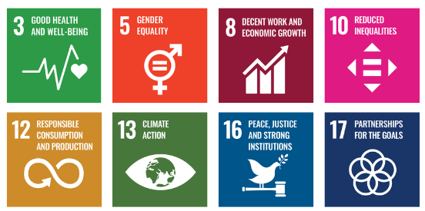

Responsibilities
- Corporate Responsibility Committee: Provides strategic oversight, approves the policy and targets, and reviews overall ESG performance and risks.
- Procurement Team: Integrates ESG criteria into sourcing and contracts and ensures suppliers comply with the Supplier Code of Conduct.
- Sustainability Team: Defines ESG standards, supports implementation, and monitors and reports performance.
- Suppliers: Comply with the Supplier Code of Conduct and participate in assessments and improvement actions.
- Human Resources: Delivers ESG and ethics training and supports diversity, equity, and inclusion initiatives.
- Senior Management: Ensures oversight, resource allocation, and enforcement of the policy through regular reviews and strategic direction.
- All Employees: Follow the policy and report any suspected violations or risks.

Monitoring, Reporting and Transparency
CTX Lifesciences Pvt. Ltd. regularly monitors its sustainable procurement performance across key areas such as ethical sourcing, supplier environmental and social compliance, health and safety standards, and regulatory adherence. Defined Key Performance Indicators (KPIs) are tracked through internal procurement and supplier management systems to assess progress against sustainability expectations. Performance is reviewed quarterly and consolidated for senior management to support responsible sourcing and risk-based decision-making. Annual evaluations identify achievements, gaps, and improvement actions, while relevant outcomes are shared with stakeholders to ensure transparency and accountability. All monitoring and reporting activities align with applicable laws, recognized sustainability frameworks, and industry best practices to ensure accuracy, consistency, and credibility.

Review Mechanism
The Sustainable Procurement Policy will be reviewed annually by the Procurement Officer to ensure its continued relevance, effectiveness, and alignment with evolving regulations, industry best practices, and business objectives. The review will be conducted in coordination with the Procurement and Sustainability Teams and relevant department heads. Supplier compliance will be monitored through regular audits, sustainability scorecards, and feedback mechanisms. Any significant revisions or enhancements to the policy will require senior management approval and will be communicated to all relevant stakeholders across the supply chain.

Effective Date | : 01.01.2026
Next Review Date | : 01.01.2027
Revision No. | : 01

Approved By:

Employee Acknowledgment Form
I acknowledge that I have read and understood the Sustainable Procurement Policy of CTX Lifesciences Pvt. Ltd. I am aware of the company’s commitment to ethical, transparent, and responsible sourcing across all goods and services.
I understand that sustainable procurement requires respecting human rights, ensuring fair labor practices throughout the supply chain, and complying with all applicable environmental and social regulations. I recognize that upholding these standards is a shared responsibility essential to the integrity and sustainability of our operations.
By signing this document, I commit to adhering to responsible sourcing practices, reporting any concerns through the designated channels, and actively participating in all required training and awareness programs. I affirm my role in supporting CTX Lifesciences’ mission to maintain a supply chain grounded in ethics, accountability, and environmental and social responsibility.

Employee Name | : _________________________
Employee ID | : _________________________
Department | : _________________________
Signature | : _________________________

